The International rhythmic gymnastics tournament “Yaroslavl Spring”
Yaroslavl, Russia
23th-27th May 2017

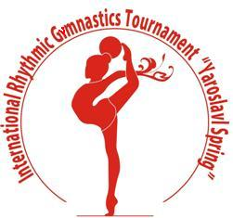

Form to be sent to:
Organising Committee/Host Federation
Organizing Committee
Rhythmic gymnastics federation of Yaroslavl
Phone/fax: +7 (4852) 72 09 76
e-mail: yargimnast@yandex.ru
http://www.yargimnast.ru

Deadline: April, 20, 2017
VISA REQUEST Form

Federation |  | Contact Person
 |  | Phone:
 |  | E-mail:

LAST NAME  First name | Function | Gender  M/F | Date of birth  dd.mm.yyyy | Citizenship and  passport N° | Passport expiry date | Arrival date | Departure date | City*
* city where the visa application support letter must be sent to
Place and date | Seal of the NF | NF authorised signature

