The International rhythmic gymnastics tournament “Yaroslavl Spring”
Yaroslavl, Russia
23th-27th May 2017

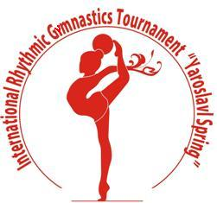

Form to be sent to:

Organising Committee/Host Federation
Organizing Committee
Rhythmic gymnastics federation of Yaroslavl
Phone/fax: +7 (4852) 72 09 76
e-mail: yargimnast@yandex.ru
http://www.yargimnast.ru

Deadline: May, 13, 2017

Travel form

Federation |  | Contact Person :  Phone:  E-mail:

vIf the team delegation is scheduled on more than one flight, please complete one (1) form for each flight.
For earlier arrival or later departure please contact the OC
Arrival information
Date |  |  |  | Arrival time
By airplane | Airport |  | Flight # |  | From
By train | Train station |  | train # |  | From
By bus | Bus station |  | Bus # |  | From
By car

Departure information
Date |  |  |  | Departure time
By airplane | Airport |  | Flight # |  | From
By train | Train station |  | Train # |  | From
By bus | Bus station |  | Bus # |  | From
By car

Place and date | Seal of the NF | NF authorised signature
…………………………………………….. |  | ……………………………………………..

