The International rhythmic gymnastics tournament “Yaroslavl Spring”
Yaroslavl, Russia
23th-27th May 2017
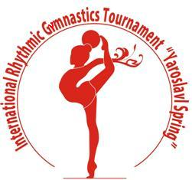

Form to be sent to:
Organizing Committee
Organizing Committee
Rhythmic gymnastics federation of Yaroslavl
Phone/fax: +7 (4852) 72 09 76
e-mail: yargimnast@yandex.ru
http://www.yargimnast.ru

Deadline: May, 10, 2017
definitive registration

Federation |  | Contact person:
 |  | Phone:
 |  | E-mail:

We will participate with:
№ | Name |  | Category | Date of birth
 |  |  |  | Day | Month | Year
1
2
3
4
5
6
7 | Judge:
8 | Coach:

Place and date | Seal of the NF | NF authorised signature
 |  | Signature of the President or Secretary General of the participating FIG affiliated NF

