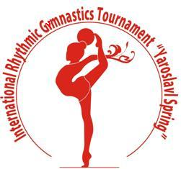
The International rhythmic gymnastics tournament “Yaroslavl Spring”
Yaroslavl, Russia
23th-27th May 2017
and the date of the World Cup

Form to be sent to:
Organizing Committee / Host Federation
Organizing Committee
Rhythmic gymnastics federation of Yaroslavl
Phone/fax: +7 (4852) 72 09 76
e-mail: yargimnast@yandex.ru
http://www.yargimnast.ru

Deadline: May, 10, 2017
ACCOMMODATION Form

Federation |  | Contact Person:
 |  | Phone:
 |  | E-mail:

Package / Hotel name | Room type | Arr. day | Dept. day | LAST NAME,  First Name | Function | Price per  person per night | # of nights | Total
 |  |  |  |  |  | GRAND TOTAL

Special requirements

Place and date | Seal of the NF | NF authorised signature

